LIBRARY MANAGEMENT SYSTEM

Technical Story Card

Revision History

Version No. | Date | Prepared by / Modified by | Significant Changes
1 | 20/2/2022 | Koppolu HarshaVardhan Reddy | Introduction added
2 | 20/2/2022 | Koppolu HarshaVardhan Reddy | Use case model added
3 | 20/2/2022 | Silpa E R | Description for user search for book added
4 | 20/2/2022 | Silpa E R | Architecture diagram added
5 | 21/2/2022 | Silpa E R | Class diagram added
6 | 25/2/2022 | Koppolu HarshaVardhan Reddy | UI screenshots added
7 | 25/2/2022 | Silpa E R | Description for UI screenshots added
8 | 6/3/2022 | Koppolu HarshaVardhan Reddy | UI screenshots modified
9 | 7/3/2022 | Silpa E R | Sequence Diagram added
10 | 15/3/2022 | Koppolu HarshaVardhan Reddy | UI screenshots modified
11 | 20/3/2022 | Silpa E R | Description of UI screenshots modified
12 | 21/3/2022 | Koppolu HarshaVardhan Reddy | UI screenshots modified
13 | 23/3/2022 | Silpa E R | Sequence diagram modified
14 | 23/3/2022 | Koppolu HarshaVardhan Reddy | Scope of change added
15 | 23/2/2022 | Silpa E R | ER diagram added
16 | 23/2/2022 | Koppolu HarshaVardhan Reddy | Use case model modified

Glossary

Abbreviation | Description
BSC | Business Story Card
TSC | Technical Story Card
DOJ | Date of joining

Table of Contents

1 Introduction 5
2 Scope of Change 5
3 List of impacted modules 5
4 Design and detailed technical updates 6
4.1 Process model 6
4.1.1 Use case Model 6
4.1.2 Architecture Diagram 8
4.1.2.1 Presentation layer 9
4.1.2.2 Application layer 9
4.1.2.3 Data layer 9
4.1.3 Class Diagram 10
4.1.4 Sequence Diagram 11
4.2 Proposed user interface design 12
4.2.1 Login page……………………………………………………………..12
4.2.2 Registration page 13
4.2.3 Home page 14
4.2.4 Search by Book name 15
4.2.5 Output page of search by Book name 16
4.2.6 Search by Author 17
4.2.7 Output page of Search by Author 18
4.2.8 Search by Category 19
4.2.9 Output page of Search by Category 20
4.3 Database design changes 21
4.3.1 ER Diagram 21
5 References 22

Introduction
- The project titled Library Management System is Library Management software for monitoring and controlling the transactions in a library. This project mainly focuses on basic operations in a library like searching books and return date of books.

- This project of “LIBRARY MANAGEMENT” helps us to search the particular book by author name, book name and category, so that we can retrieve the details of books available in the library. We can also check the particular book is issued or stock available in the library. In this project we can know the return date of the issued book from the library.

- Throughout the project the focus has been on presenting information and comments in an easy and intelligible manner. The project is very useful for those who want to know about Library Management System.

Scope of Change
- A status page for all users to view books borrowed by them, their individual due dates and their individual penalties if any. Mechanism to reset the password in case user forgets it. The facility to reserve books that are available.

List of impacted modules
- All the functional modules will be created from scratch.

Design and Detailed technical updates

Process model

Use case Model

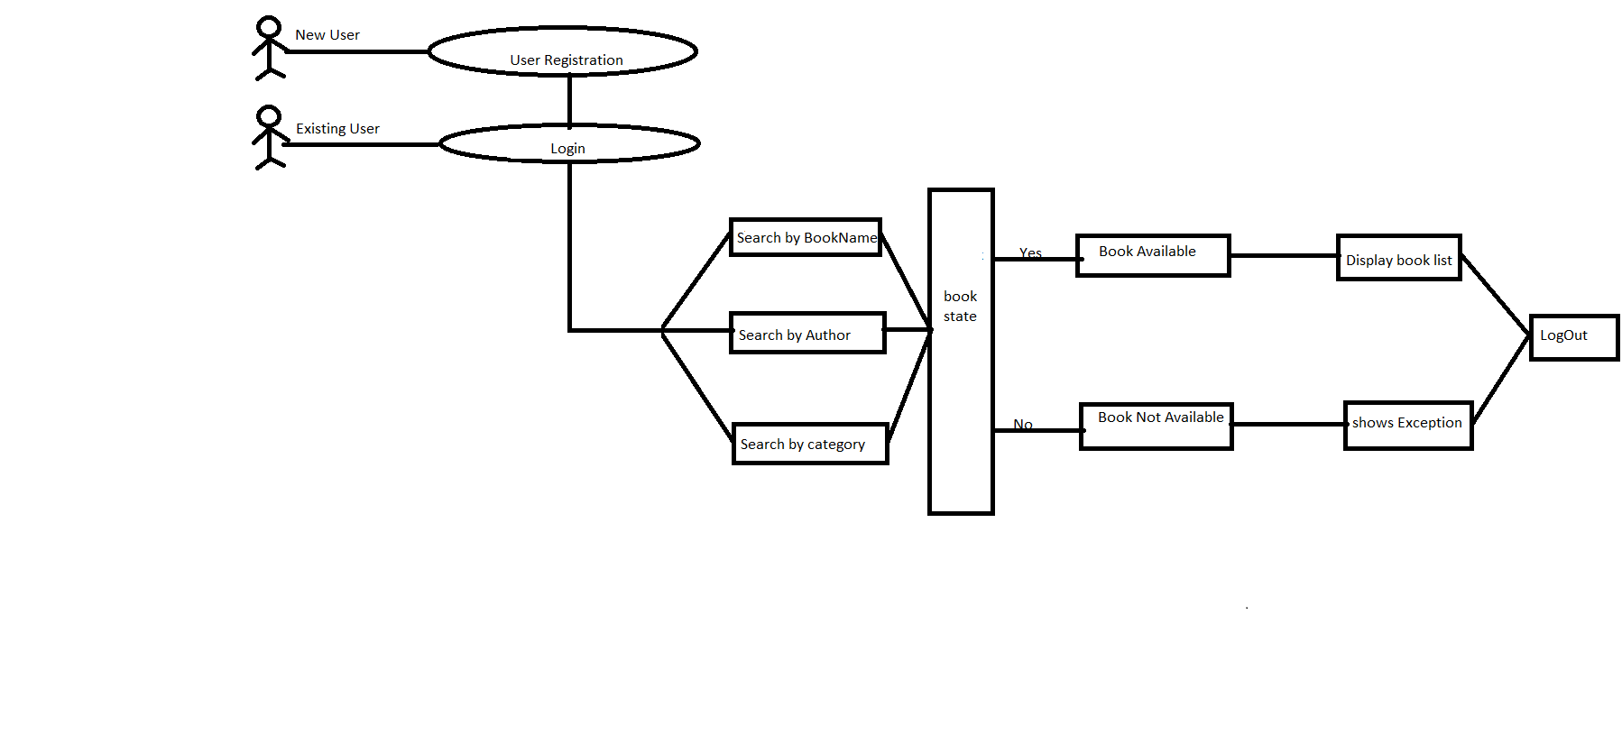

Brief Description | User search for book
Basic Flow | User can search for a book by three options  - Search by Bookname  - Search by Authorname  - Search by Category  Using any of these options user will search for the book. It will display the availability of books with book details like BookNo,BookName,Author and Category.
Alternate Flow | The system will validate the information provided. If the book is not available the input form will be redirected with error message like BookNotFoundException.
Validation | Bookname/Authorname/Category is required and minimum 3 characters and max 30 characters.
Pre-Conditions | User should have network access and Browser with latest updates.
Post-Conditions | Book status will be displayed.

4.1.2 Architecture Diagram

Layer
Logical View
Technology/ Framework

UI Components
Presentation Layer
HTML5/ CSS3/ typescript 4.5.5/ Angular8
Login
Output
Registration

Book Home

Web-Server Classes
Java 1.8/Spring boot 2.3.3
Application/ Business Layer
Configuration
Controllers

Service
REST Controllers

Entity/ Model Classes

Data Access Layer
Repository classes
Spring Data JPA

Oracle 11g Database

4.1.2.1 Presentation Layer:

This layer consists of all UI components.
- Bookname Component: User can use the Bookname component to search for a book by it’s bookname.
- Authorname component: User can use the Authorname component to search for a book by it’s authorname
- Category component: User can use the Category component to search for a book by it’s category
- Search component: By using search component user can search for a book by its Bookname/Authorname/Category.

4.1.2.2 Application Layer:

This layer comprises of all server and business classes.
- Configuration settings (XML or Class based) will define the application and server configuration.
- Spring Controllers defines the server classes, which are required to process the incoming http requests.
- Service classes are required to perform the required business services.
- REST Controllers to process the HTTP AJAX requests.
- Model classes are used the define the functions of the entities present in the system.

4.1.2.3 Data Layer:

Data layer is implemented through Spring Data JPA. It will contain the repository classes, which provides interface to the table.

4.1.3 Class Diagram

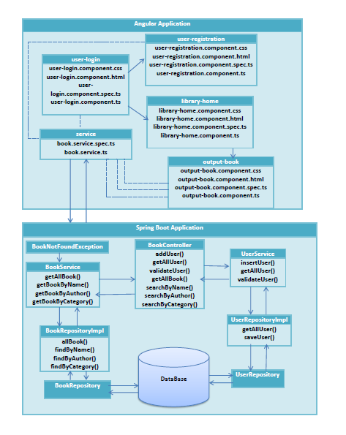

4.1.4 Sequence diagram

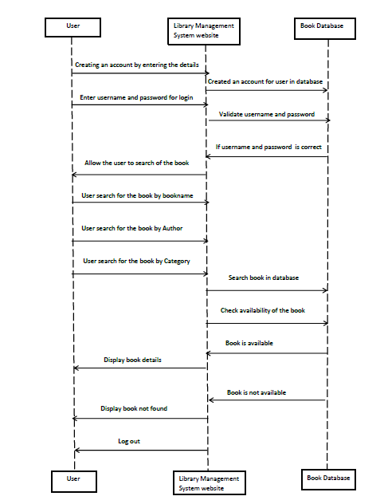

4.2 Proposed user Interface design
4.2.1 Login page

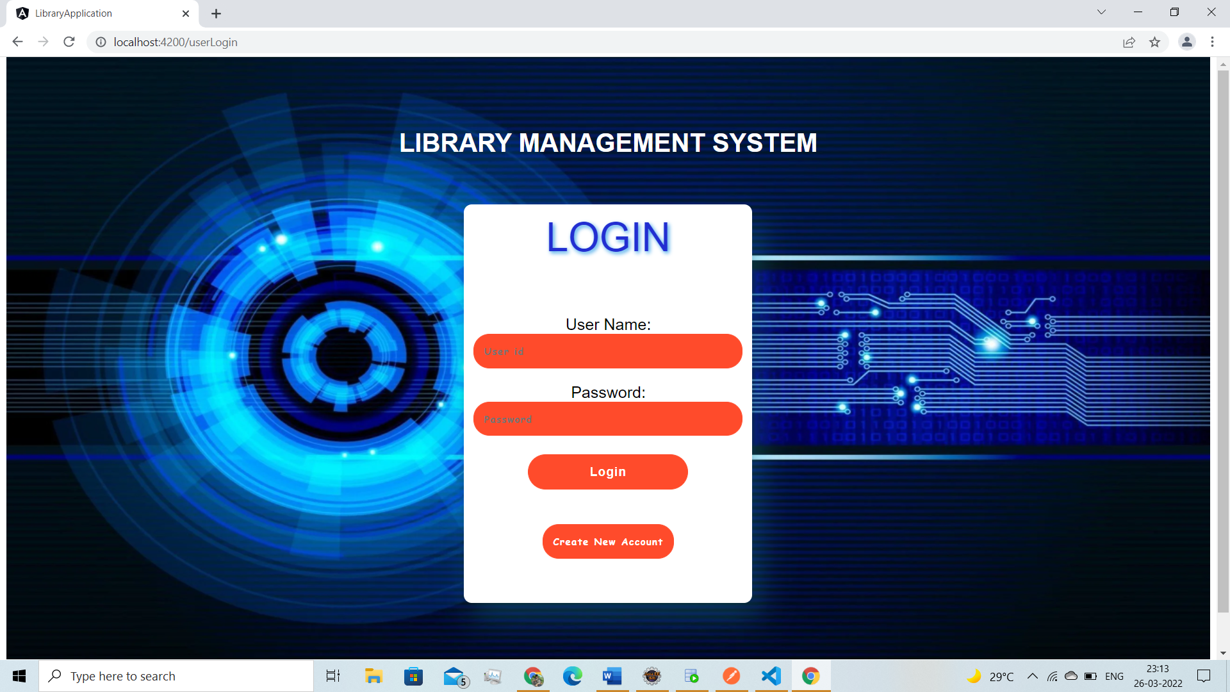

Brief Description | Login
Basic Flow | This page describes how a user log-in in to the system  - The user has to login himself into the system.  - After the successful login, user will be taken to the appropriate landing page.  - The following information is required to login.  - username  - password
Alternate Flow | - The system will validate the credentials provided. If credentials are invalid, login form will be redirected again with error message.
Validation | - Valid username  - Valid password
Pre-Conditions | User should have network access and Browser with latest updates.
Post-Conditions | Welcome page has to be displayed.
4.2.2 Registration Page

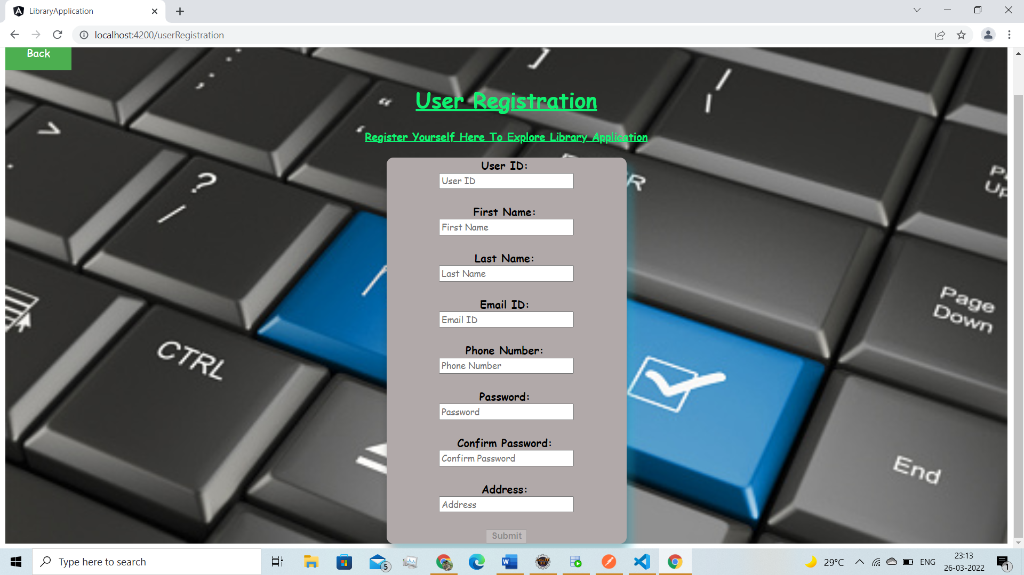

Brief Description | Registration
Basic Flow | - This page is for registering the new customer  - The customer has to give all his details like first name, last name, contact number, email id, residential address, user id, password.
Alternate Flow | The system will collect all the data given and store them in database.
Validation | Valid contact number, email id and password must be given
Pre-Conditions | User should have network access and Browser with latest updates.
Post-Conditions | Login page has to be displayed.

4.2.3 Home page

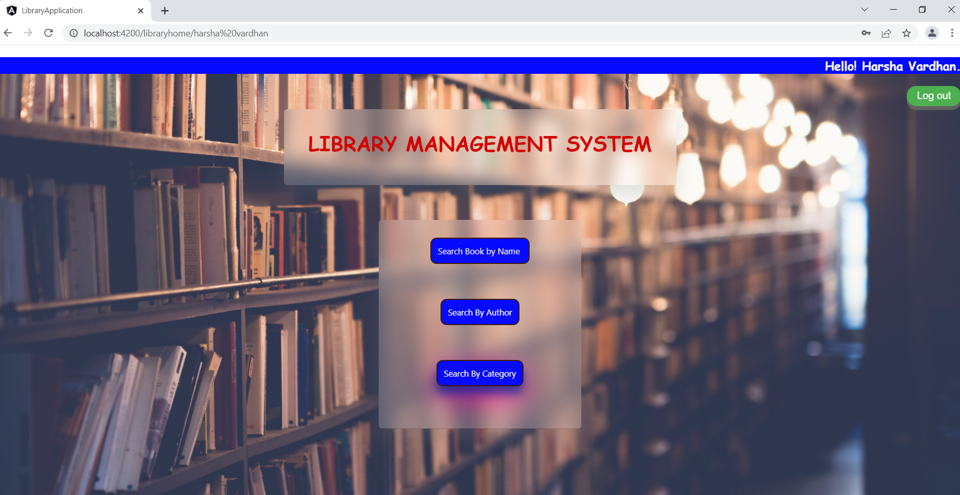

Brief Description | Home page
Basic Flow | User can search for a book by three options  - Search by Bookname  - Search by Authorname  - Search by Category
Alternate Flow | The system will validate the information provided. If the book is not available the input form will be redirected with error message like BookNotFoundException.
Validation | Bookname/Authorname/Category is required and minimum 3 characters and max 30 characters.
Pre-Conditions | User should have network access and Browser with latest updates.
Post-Conditions | Book status will be displayed.

4.2.4 Search by Book Name

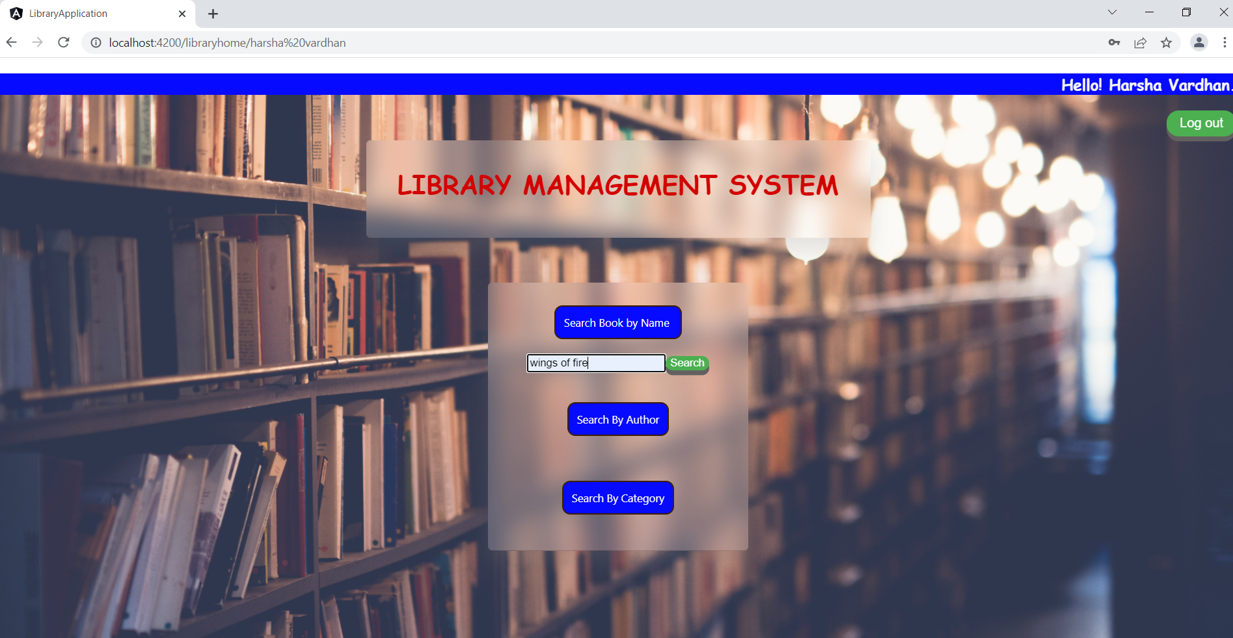

Brief Description | Search by BookName
Basic Flow | User will search for the book by entering the book name and then click on search button. It will display the availability of books with book details like BookNo,BookName,Author and Category.
Alternate Flow | The system will validate the information provided. If the book is not available the input form will be redirected with error message like BookNotFoundException.
Validation | Valid bookname is required and minimum 3 characters and max 30 characters.
Pre-Conditions | User should have network access and Browser with latest updates.
Post-Conditions | Book status will be displayed.

4.2.5 Output page of search by book name

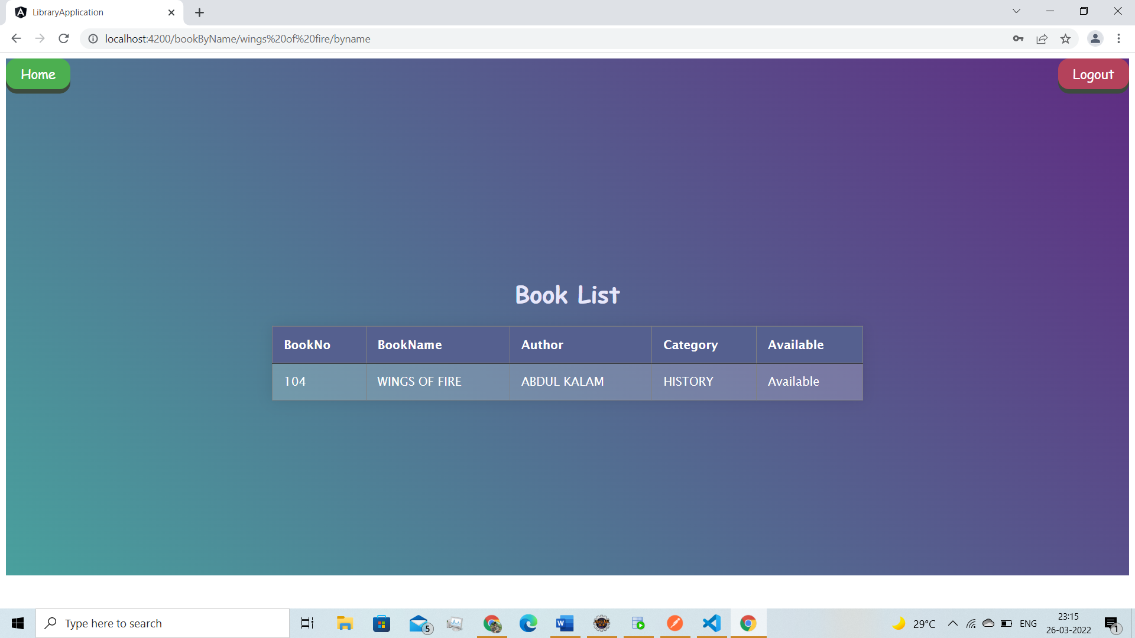

Brief Description | Output page of Search by BookName
Basic Flow | User will search for the book by entering the book name and if the book is available display book details like BookNo, BookName, Author and Category.
Alternate Flow | The system will validate the information provided. If the book is not available the input form will be redirected with error message like BookNotFoundException.
Validation | Valid bookname is required and minimum 3 characters and max 30 characters.
Pre-Conditions | User should have network access and Browser with latest updates.
Post-Conditions | Book status will be displayed.

4.2.6 Search by Author

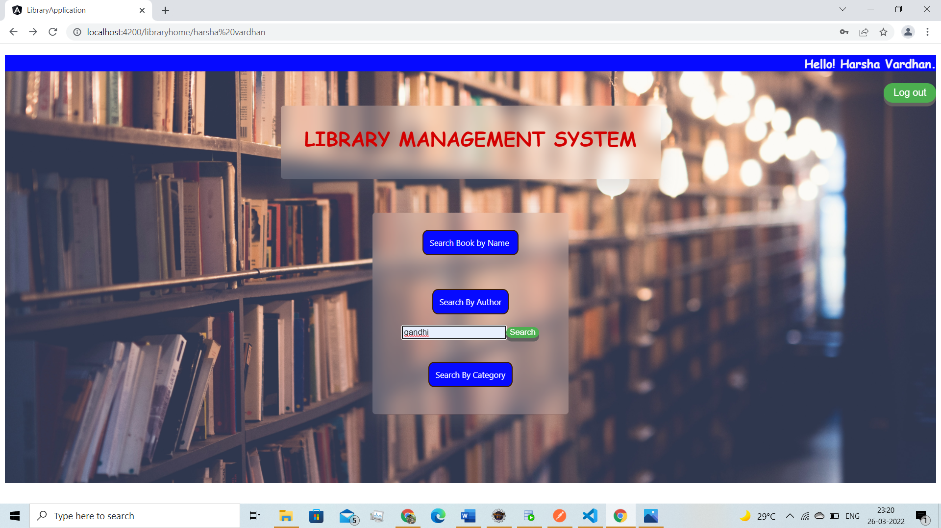

Brief Description | Search by Author
Basic Flow | User will search for the book by entering the Author name and then click on search button. It will display the availability of books with book details like BookNo,BookName,Author and Category.
Alternate Flow | The system will validate the information provided. If the book is not available the input form will be redirected with error message like BookNotFoundException.
Validation | Valid Authorname is required and minimum 3 characters and max 30 characters.
Pre-Conditions | User should have network access and Browser with latest updates.
Post-Conditions | Book status will be displayed.

4.2.7 Output page of search by Author

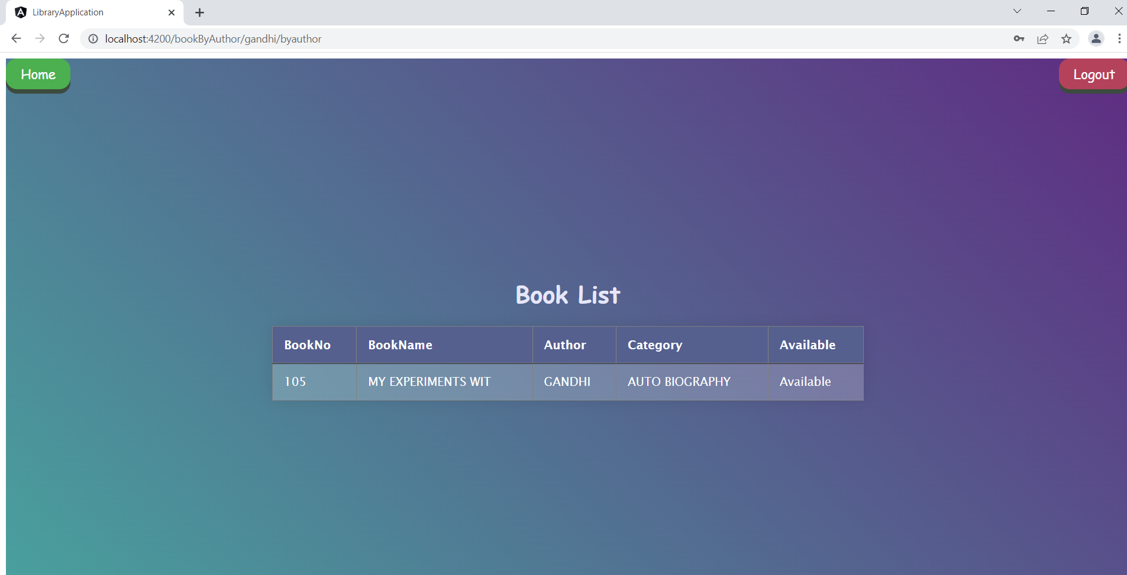

Brief Description | Output page of Search by Author
Basic Flow | User will search for the book by entering the Author name and if the book is available display book details like BookNo, BookName, Author and Category.
Alternate Flow | The system will validate the information provided. If the book is not available the input form will be redirected with error message like BookNotFoundException.
Validation | Valid Authorname is required and minimum 3 characters and max 30 characters.
Pre-Conditions | User should have network access and Browser with latest updates.
Post-Conditions | Book status will be displayed.

4.2.8 Search by Category

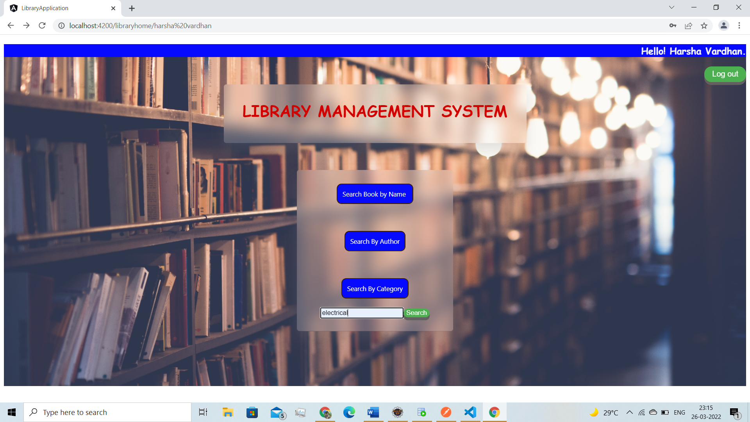

Brief Description | Search by Category
Basic Flow | User will search for the book by entering the category of book and then click on search button. It will display the availability of books with book details like BookNo,BookName,Author and Category.
Alternate Flow | The system will validate the information provided. If the book is not available the input form will be redirected with error message like BookNotFoundException.
Validation | Valid Category of book is required and minimum 3 characters and max 30 characters.
Pre-Conditions | User should have network access and Browser with latest updates.
Post-Conditions | Book status will be displayed.

4.2.9 Output page of search by Category

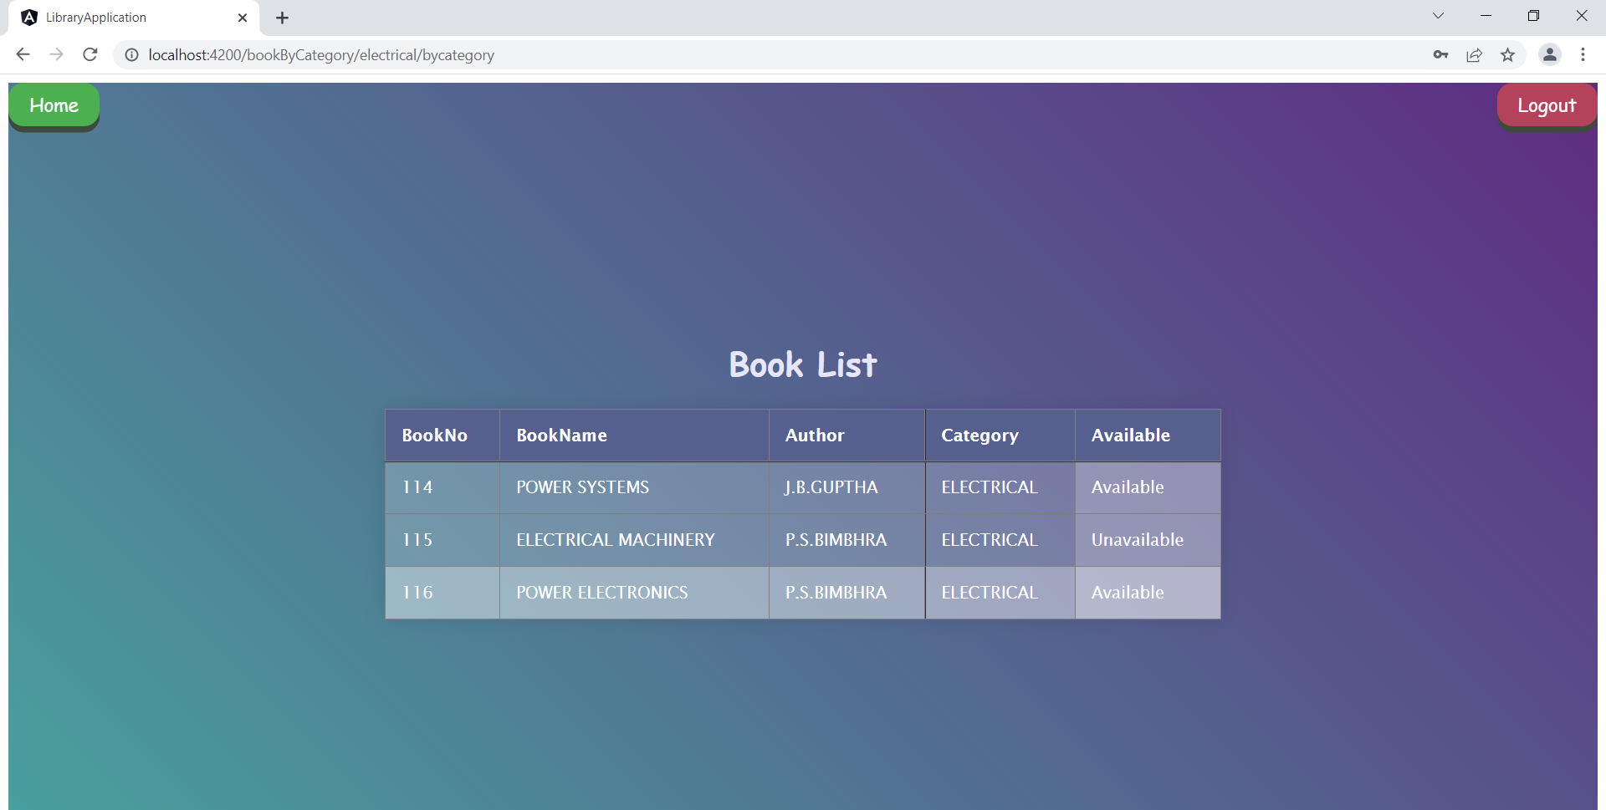

Brief Description | Output page of Search by Category
Basic Flow | User will search for the book by entering the category of book and if the book in that category is available display book details like BookNo, BookName, Author and Category.
Alternate Flow | The system will validate the information provided. If the book is not available the input form will be redirected with error message like BookNotFoundException.
Validation | Valid Category of book is required and minimum 3 characters and max 30 characters.
Pre-Conditions | User should have network access and Browser with latest updates.
Post-Conditions | Book status will be displayed.

4.3 Database design changes

4.3.1 ER Diagram

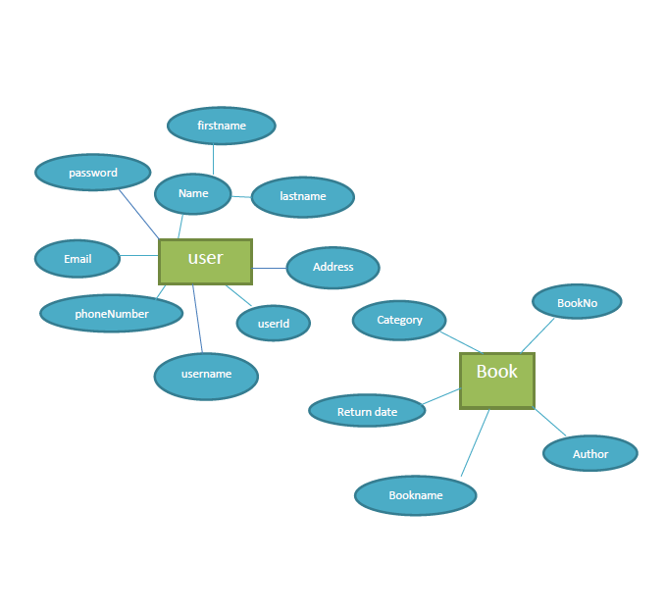

References
- As a team, we have reffered LMS content to complete our project named as “Library Management System”. HCL provided three months training for us on that particular training we learnt so many technologies like Core Java, HTML5, CSS3, Spring boot2.3.3,Spring Data JPA,Angular8 .Whatever we learnt in the training we implement in our project.

